Daily Morning Routine for Weight Loss (30–60 Year Age Group)

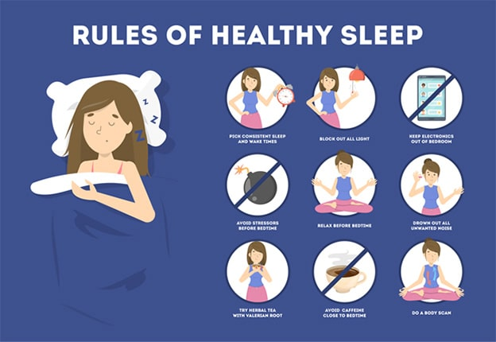

4
Weight loss after the age of 30 is no longer just about “eating less and moving more.” Hormonal changes, slower metabolism, work stress, joint issues, and lifestyle diseases make weight management more complex—especially between 30 and 60 years of age.
The good news?
A consistent and age-appropriate morning routine can significantly boost fat loss, improve metabolism, regulate hormones, and set the tone for a healthy day—without extreme diets or exhausting workouts.
This guide explains a simple, science-backed morning routine that works for both men and women, whether you’re 35, 45, or 58.

Why Morning Routine Matters More After 30
As we age:
- Basal metabolic rate gradually declines
- Insulin sensitivity reduces
- Muscle mass decreases (sarcopenia)
- Stress hormones like cortisol increase
A well-designed morning routine helps:
- Activate metabolism early
- Improve insulin response
- Preserve muscle mass
- Reduce stress-related fat gain
👉 Consistency matters more than intensity.

Ideal Morning Routine Timeline (Overview)
Time | Activity
6:00–6:15 | Wake up + hydration
6:15–6:30 | Gentle mobility & stretching
6:30–7:00 | Walking / yoga / light workout
7:00–7:10 | Breathing or meditation
7:10–7:30 | Healthy breakfast
7:30 onward | Active lifestyle mindset
Let’s break each step down.

1. Wake Up at a Consistent Time (Most Underrated Step)
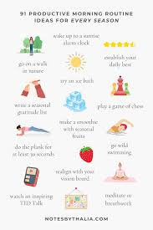
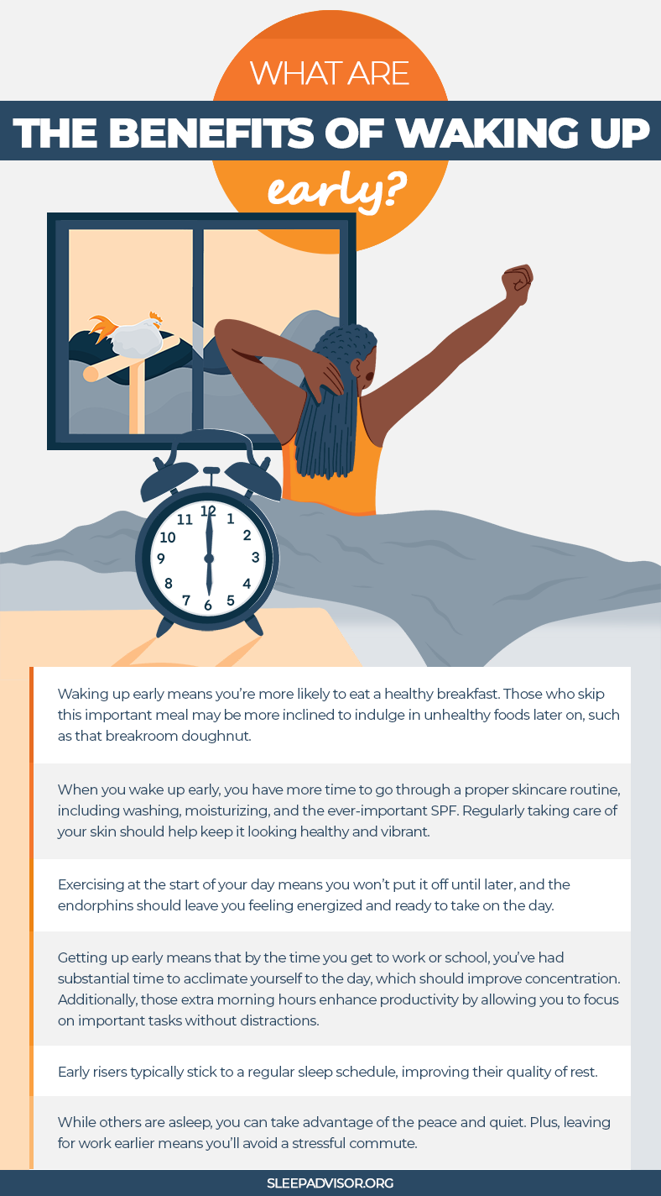
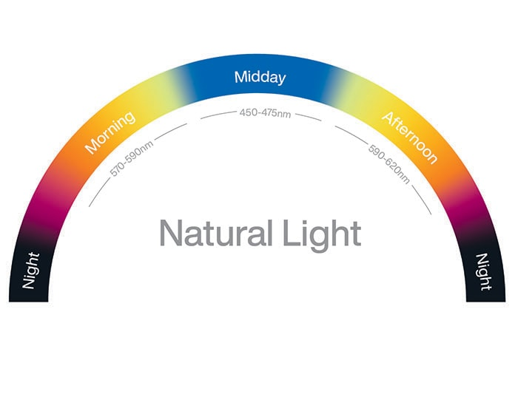
Why it matters:
Irregular sleep and wake times disrupt circadian rhythm, which directly affects weight gain.

Best practice
- Wake up between 5:30–6:30 AM
- Aim for 7–8 hours of sleep
- Avoid checking phone immediately
Weight loss benefit
- Better hormone balance (leptin & ghrelin)
- Reduced late-night cravings
- Improved energy for physical activity

2. Start with Hydration (Fat Loss Begins Here)
After 6–8 hours of sleep, your body is dehydrated.

What to drink
- 1–2 glasses of lukewarm water
- Optional additions:
  - Lemon (improves digestion)
  - Soaked methi seeds (supports insulin control)
  - Plain water is perfectly fine
⚠️ Avoid:
- Sugary drinks
- “Detox” products with unrealistic claims
Weight loss benefit
- Boosts metabolism by up to 10–20%
- Reduces false hunger signals
- Improves digestion and bowel movement

3. Gentle Mobility & Joint Warm-Up (Especially 40+)
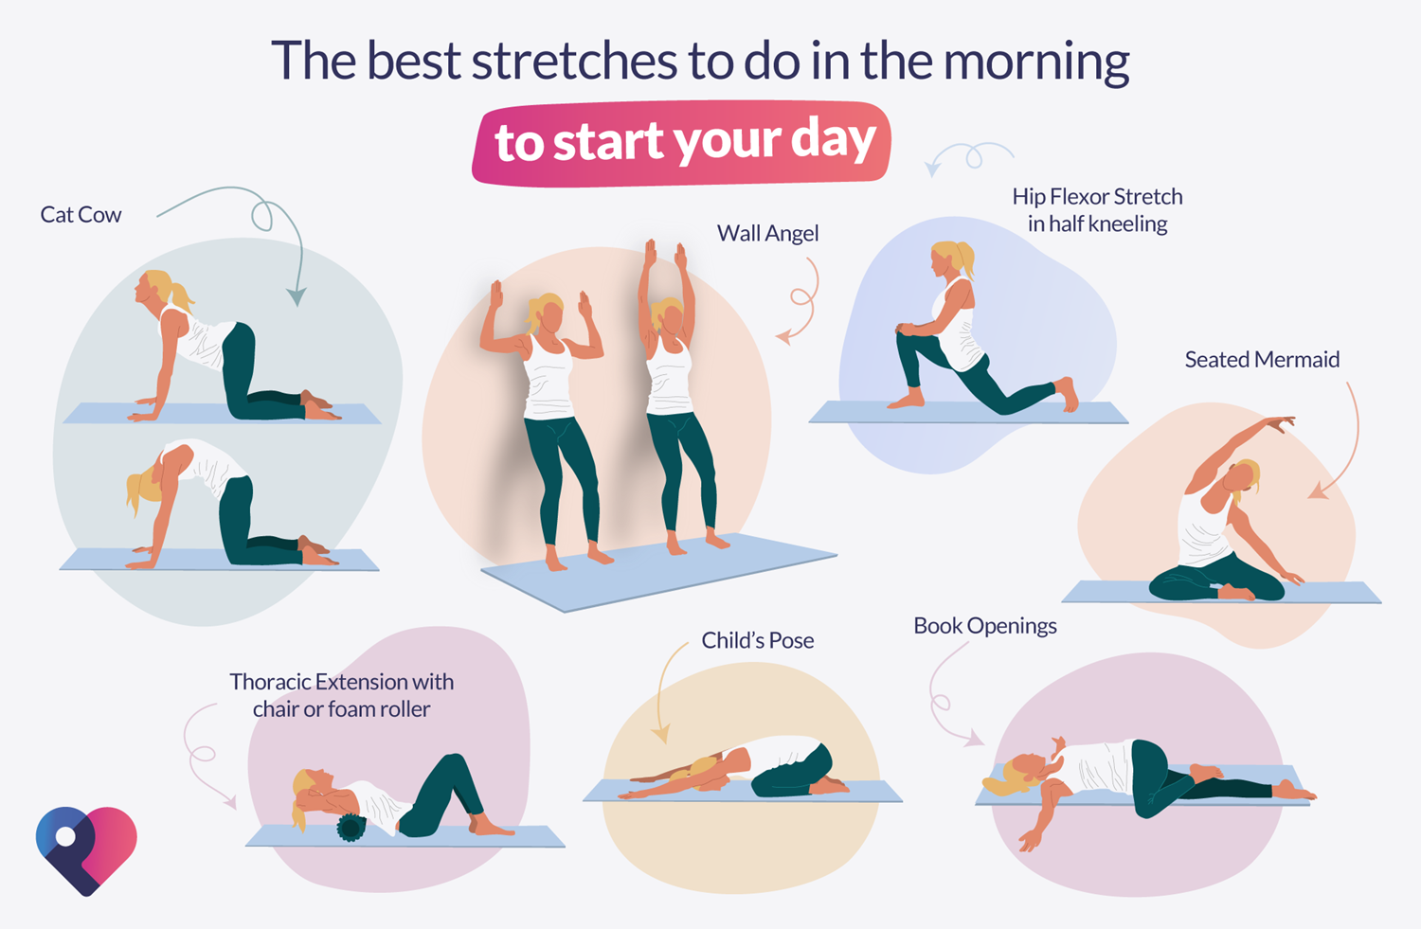
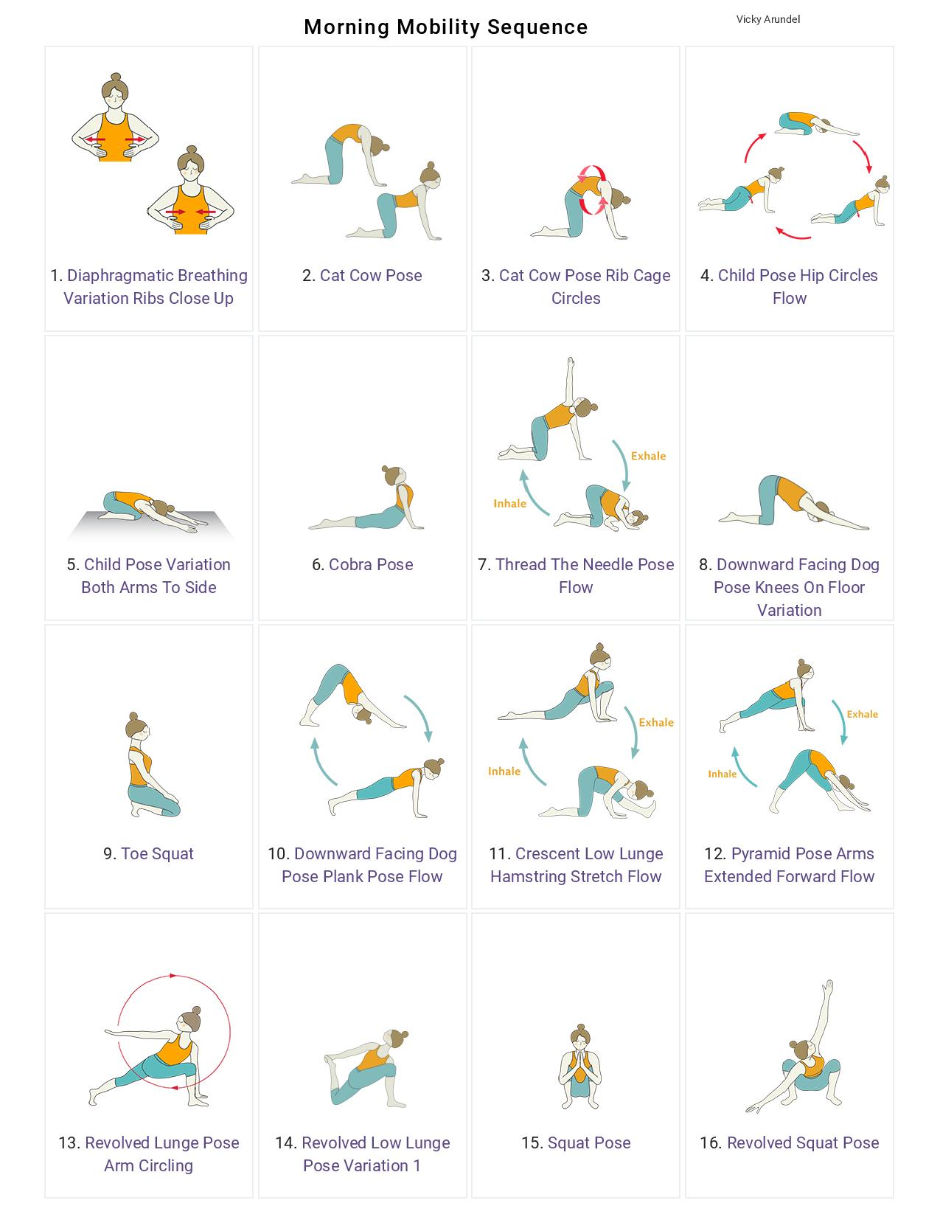

For adults above 30—especially 45+—jumping straight into workouts can cause injury.

10–15 minutes of:
- Neck rolls
- Shoulder rotations
- Hip circles
- Ankle and knee movements
- Light stretching
Weight loss benefit
- Improves blood circulation
- Prevents injury
- Makes workouts more effective
👉 Think “prepare the body,” not “push the body.”

4. Morning Physical Activity (30 Minutes Is Enough)


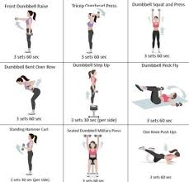
You do not need intense gym sessions. The best exercise is the one you’ll do consistently.

Best options by age
30–40 years
- Brisk walking
- Jog-walk combo
- Bodyweight exercises
40–50 years
- Fast walking
- Yoga (Surya Namaskar)
- Resistance bands
50–60 years
- Walking
- Chair yoga
- Light strength training
⏱ Duration: 20–40 minutes
Weight loss benefit
- Burns stored fat
- Improves insulin sensitivity
- Preserves muscle mass

5. Sunlight Exposure (Free Fat-Loss Tool)
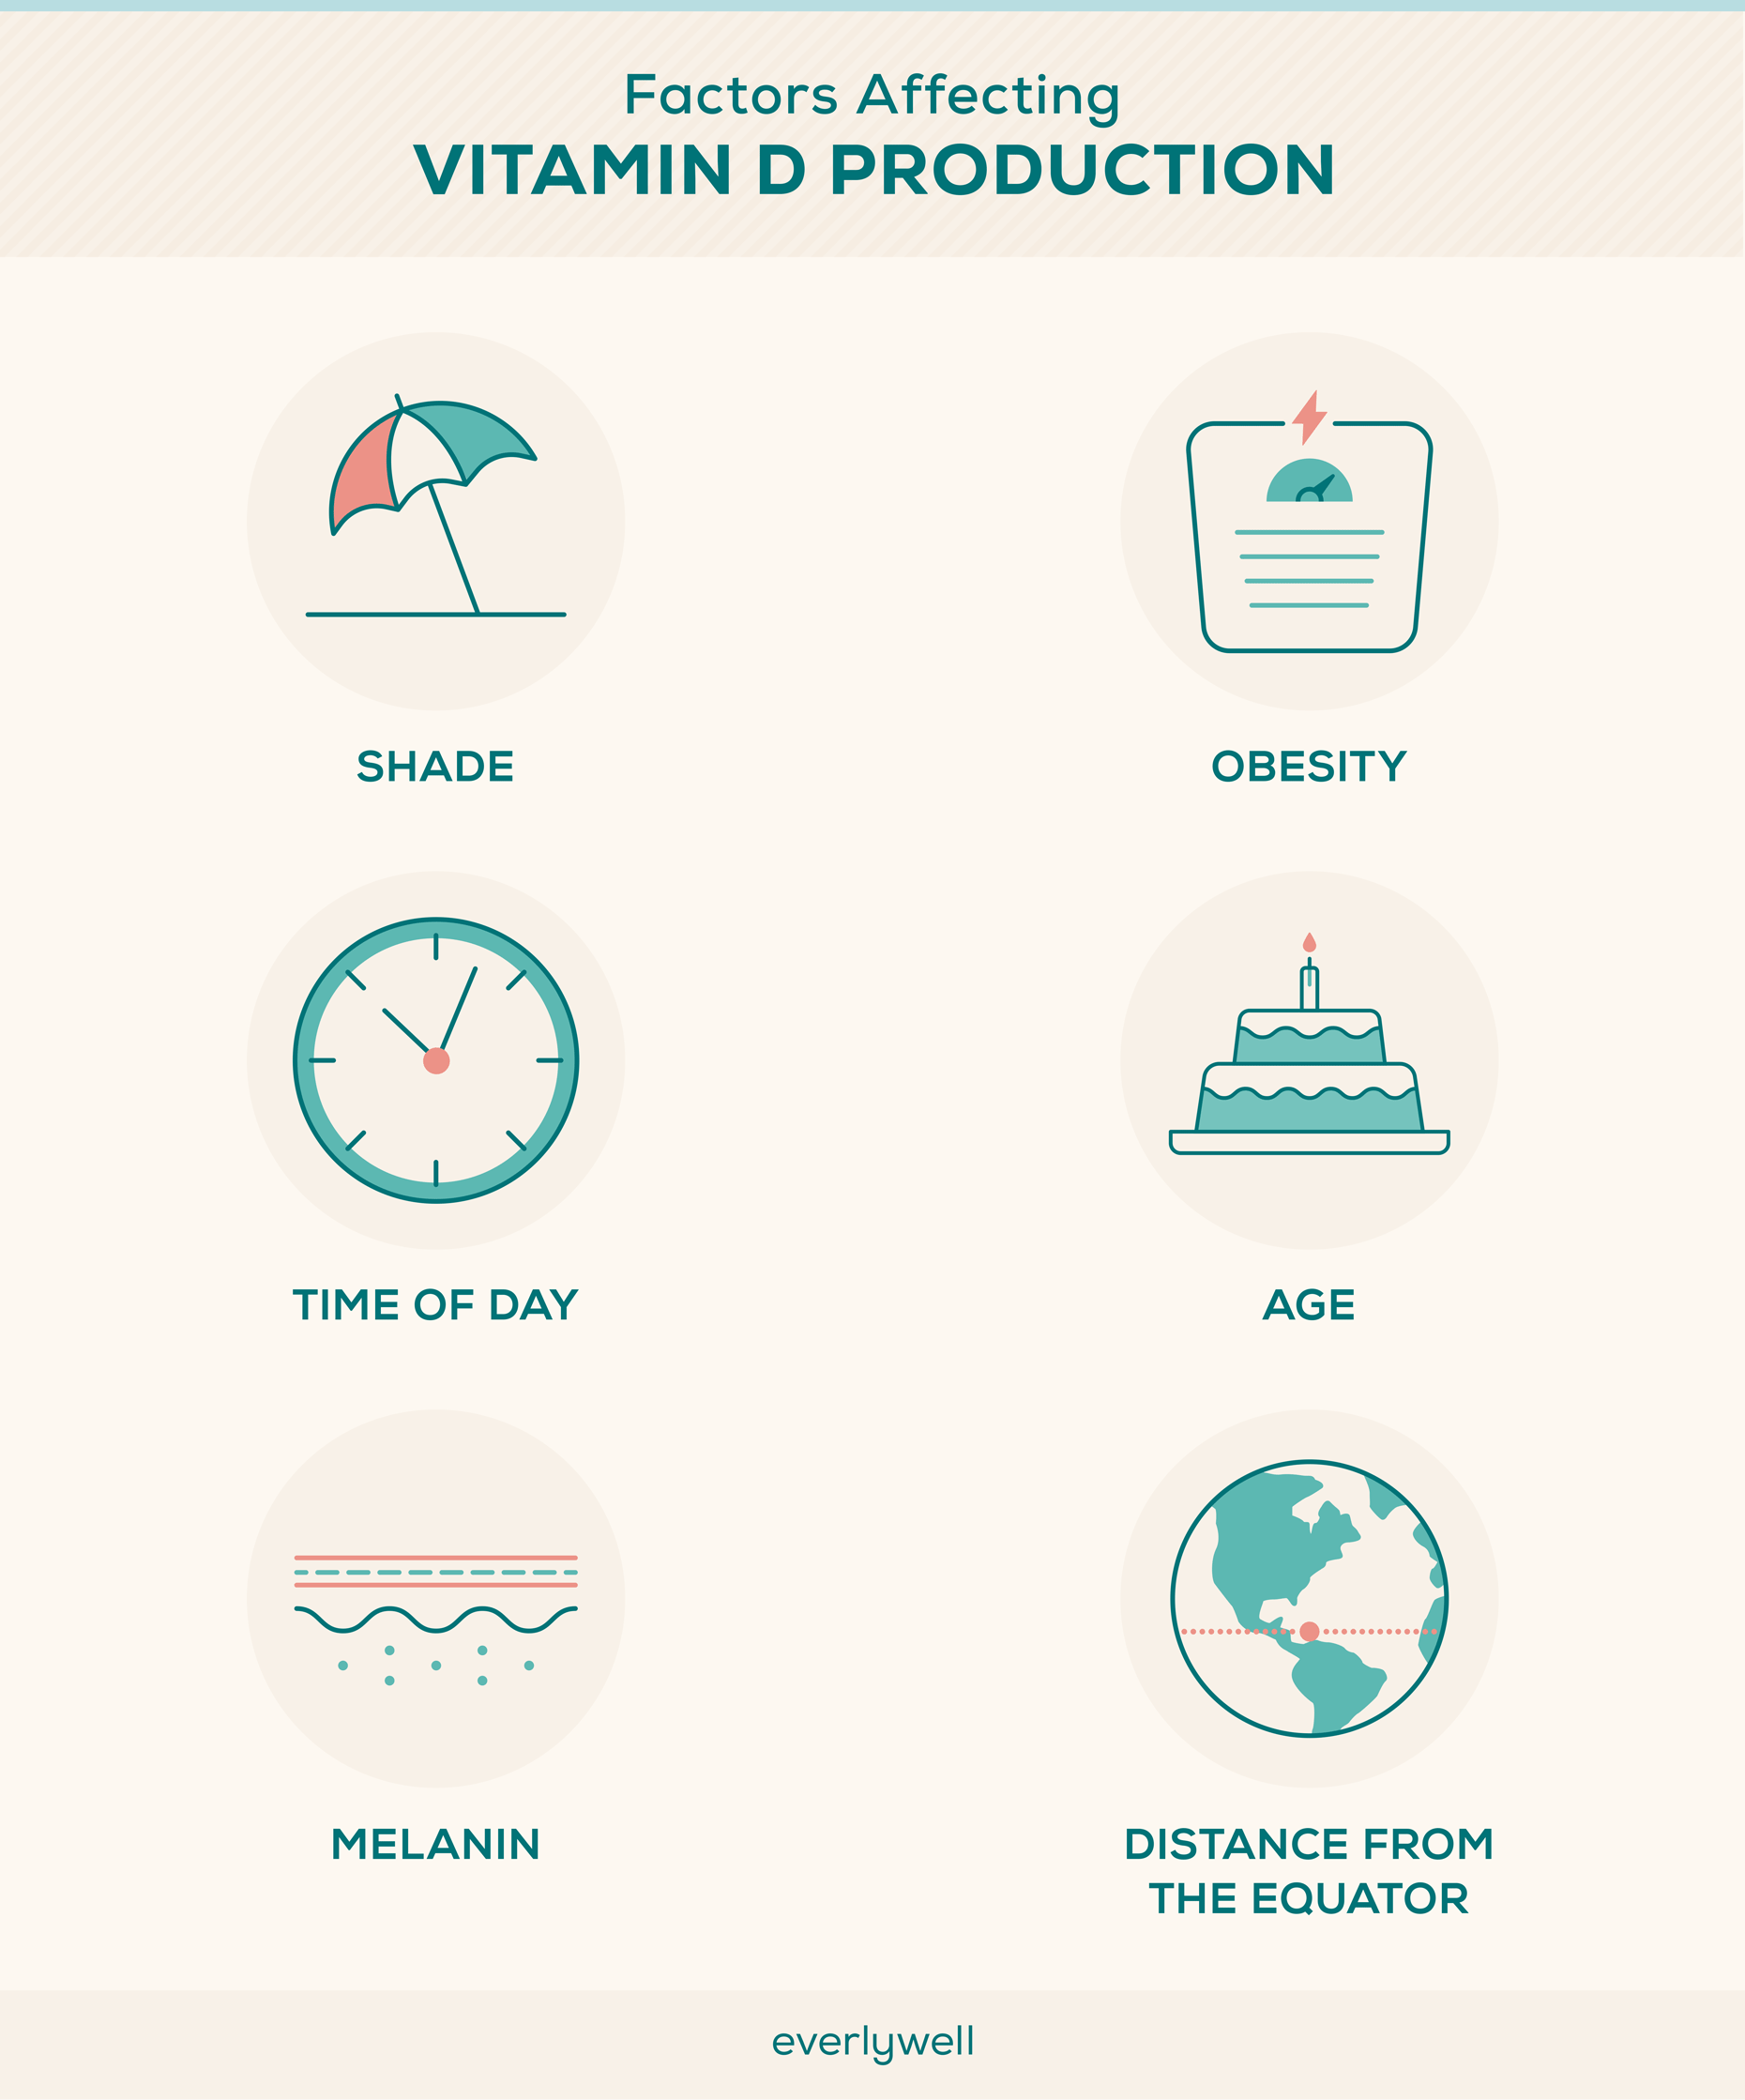


Morning sunlight helps regulate:
- Vitamin D
- Melatonin
- Cortisol rhythm

How
- Walk outdoors
- Sit near sunlight for 10–15 minutes
- Avoid sunglasses during early sun
Weight loss benefit
- Better sleep quality
- Reduced belly fat
- Improved mood and motivation

6. Breathing or Meditation (Stress = Weight Gain)
Stress increases cortisol, which promotes abdominal fat storage—very common after 35.

Simple practices (5–10 minutes)
- Deep belly breathing
- Anulom Vilom
- Mindful silence
- Gratitude reflection
Weight loss benefit
- Controls emotional eating
- Improves hormonal balance
- Enhances consistency

7. Healthy Breakfast (Don’t Skip After 30)



Skipping breakfast may work at 25—but not always after 35.

Ideal breakfast components
- Protein: eggs, paneer, dal, curd
- Fiber: fruits, vegetables, oats
- Healthy fats: nuts, seeds

Sample breakfast ideas
- Vegetable omelette + fruit
- Oats with nuts and seeds
- Dal chilla with curd
- Greek yogurt with fruits
⚠️ Avoid:
- Sugary cereals
- Fried items
- Bakery foods
Weight loss benefit
- Prevents overeating later
- Stabilizes blood sugar
- Improves metabolism

8. Morning Habits That Sabotage Weight Loss
Avoid these common mistakes:
- ❌ Checking phone for 30 minutes
- ❌ Skipping hydration
- ❌ Doing intense workouts without warm-up
- ❌ Skipping breakfast entirely
- ❌ Stressful news consumption early morning
Small habits compound over time—positively or negatively.

9. Consistency Over Perfection (The Real Secret)
For adults aged 30–60:
- 80% consistency beats 100% intensity
- Missed days don’t matter—quitting does
- Progress may be slow but sustainable

Track simple metrics
- Waist size
- Energy levels
- Sleep quality
- Mood and mobility
Weight loss is not just about the scale.

10. Sample 7-Day Morning Routine Plan
Day | Activity
Mon | Walk + stretching
Tue | Yoga + breathing
Wed | Resistance bands
Thu | Walk + sunlight
Fri | Bodyweight exercises
Sat | Light yoga
Sun | Active rest / leisure walk

Final Thoughts: Build a Morning You Can Live With
Weight loss between 30 and 60 is not about extremes. It’s about:
- Hormone-friendly habits
- Joint-safe movement
- Stress control
- Consistent mornings
Start small. Even 30 minutes each morning, done daily, can lead to:
- Reduced belly fat
- Better energy
- Improved mobility
- Long-term weight control
Your morning routine is not just about weight loss—it’s about adding healthy years to your life.

